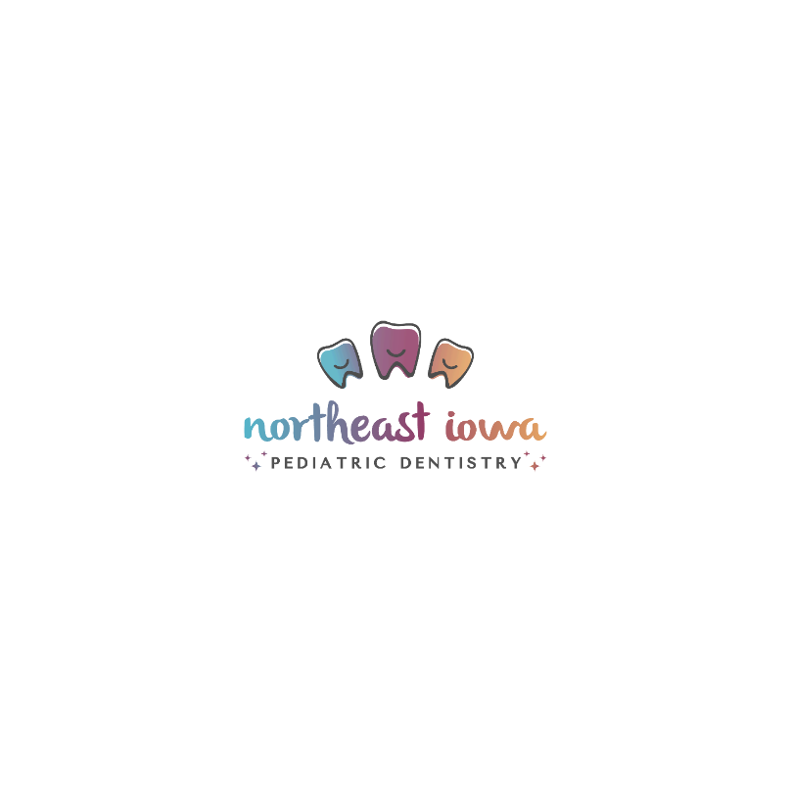

Dr. Annie’s Favorite Toothpastes & Dental Products

|  |  |  |
| --- | --- | --- |
| **Tanner’s Tasty Paste**  Vanilla Bling  Cha Cha Chocolate  Orange Creamsicle*  (SLS Free, Gluten Free)  *Fluoride free options available | Non-foaming formula,  SLS free (avoids canker sores), dye-free | **FOUND AT:**  Amazon https://www.tannerstastypaste.com/ |
| **Hello**  Strawberry, Grape, Bubble Gum,  Blue Raspberry  (SLS Free, Gluten Free)  *Fluoride free options available | SLS free (avoids canker sores),  contains glycerin, Vegan, dye-free | Amazon, Walmart https://www.hello-products.com/ |
| **Tom’s of Maine**  Silly Strawberry, Orange Mango, Blueberry, Grape  ***(contains SLS)***  *Fluoride free options available | Dye-free, contains glycerin, Vegan | Amazon, Walmart  https://www.tomsofmaine.com/ |
| **OraNurse**  Flavor Free  (SLS Free)  *Non-foaming + non-flavored* | Oranurse 50ml Unflavoured Toothpaste  Great option for children with special health care needs and/or sensory conditions, contains glycerin | Amazon, Walmart online https://oranurse.co.uk/ |
| **Dr. Bob’s**  *\*Mostly* Flavor Free  (SLS free, Gluten free) | A picture containing text  Description automatically generated  Minimal flavor (slightly sweet),  dye-free, all-natural | Amazon https://www.drboboralcare.com/ |
| **Squigle**  Semi-sweet mint flavor  (SLS Free) | A blue and white license plate  Description automatically generated with low confidenceHighest content of xylitol, SLS free (avoids canker sores), contains glycerin | Amazon, Walmart online |
| **Sensodyne**  Fresh Mint  (SLS free) | Image for Sensodyne® Fresh MintMinimal flavor (sweet)  dye-free, all-natural, SLS free,  ***ADA proven to reduce sensitivity*** | Amazon, Walmart |
| **PreviDent 5000**  *Multiple Flavors*  **Clinpro 5000** | PreviDent® 5000 Prescription Toothpaste | Colgate®Image for 3M™ Clinpro™ 5000 Toothpaste  High fluoride toothpaste  (5x amount than in regular toothpastes),  good for individuals at high risk for decay | Prescription Required |
| **Floss “Handles”** | https://m.media-amazon.com/images/W/IMAGERENDERING_521856-T1/images/I/81K0mHvV4+L._SL1500_.jpgproduct image 4 of 8 slides  Glide floss (handles or manual) work best if multiple fillings are present | https://m.media-amazon.com/images/W/IMAGERENDERING_521856-T1/images/I/71z0M60QFWL._SL1500_.jpg  Amazon, Walmart  Tip: “Y” shaped flossers  reach back teeth easier |
| **Gum Chuck Flossers**  (Dr. Annie’s favorite!) | GumChucks Kids Starter Packhttps://m.media-amazon.com/images/W/IMAGERENDERING_521856-T1/images/I/51NqCgSI8zL.jpg | Amazon, https://gumchucks.com/ |
| **Orthodontic Flossers** | Oral B Superfloss  Super Floss (Amazon) | Platypus™ Ortho Flossers | Safco Dental SupplyPlatypus Flossers  Amazon |
| **Surround Toothbrush**  (3-sided)  Specialized Care Co. | Specialized Care Co. – BluestoneAmazon.com : Surround® Toothbrush (Pack of 2) (blue/coral) : Health &  Household | Amazon, https://specializedcare.com/ |
| **Mouth Rests**  Specialized Care Co. | Mouth RestsSpecialized Care Open Wide Disposable Mouth Rest - Celtic Marketing | Amazon, https://specializedcare.com/ |